Use case scenarios

add timeline

Preconditions:

1. Software is fully loaded on the device.

Description: The user clicks on File 🡪 New 🡪 Timeline to create a timeline. A new box appears asking for input from the user. Title, description, date (start & end), time (start & end).   
The user clicks on the “Create” button, then the window disappears, a timeline with days show up on the main window. Software saves the timeline and its values in a text file.

Exceptions: Display mode does not give you the option to edit or create a timeline. When clicking on the “cancel” button, the new window shuts down. When not filling in the necessary conditions, the “create” button does not work.

C:\Users\kiwi\AppData\Local\Microsoft\Windows\INetCache\Content.Word\Add Timeline.png

add event with duration

Preconditions:

1. Software is fully loaded on the device.
2. Timeline has been created.

Description: The user clicks on File 🡪 New 🡪 Event or the “add event” button on the main window, to create an event. A new box appears asking for input from the user. Title, description, date (start & end), time (start & end), picture. The user clicks on the “Create” button, then the window disappears, an event with days show up on the current timeline on the main window. Software saves the event values to its timeline, in a text file.

Exceptions: Display mode does not give you the option to edit or create an event. When clicking on the “cancel” button, the new window shuts down. When not filling in the necessary conditions, the “create” button does not work.

C:\Users\kiwi\AppData\Local\Microsoft\Windows\INetCache\Content.Word\add event with duration.png

modify event

Preconditions:

1. Timeline has been created.
2. Event with or without duration has been created.

Description: The user clicks on Edit 🡪 Event 🡪 Update Event. New window appears, user has the option to change: title, picture, description, start- and –end time (if not already added, user is able to add duration). User clicks on “update”, the new window disappears and new values are shown on the current timeline. The software saves the new values to the text file belonging to that timeline.

Exceptions: Display mode does not give you the option to edit or create an event. Clicking on cancel makes the window disappear. When not filling in the necessary conditions, the “update” button does not work.

C:\Users\kiwi\AppData\Local\Microsoft\Windows\INetCache\Content.Word\Modify event.png

add event without duration

Preconditions:

1. Create mode has been chosen.
2. Timeline has been created.
3. The option to add an event without duration has been chosen.

Description The user clicks on File 🡪 New 🡪 Event or the “add event” button on the main window, to create an event. A new box appears asking for input from the user. Title, description, date (start), time (start), picture. The user clicks on the “Create” button, then the window disappears, an event with days show up on the current timeline on the main window. Software saves the event values to its timeline, in a text file.

Exceptions: Display mode does not give you the option to edit or create an event. When clicking on the “cancel” button, the new window shuts down. When not filling in the necessary conditions, the “create” button does not work.

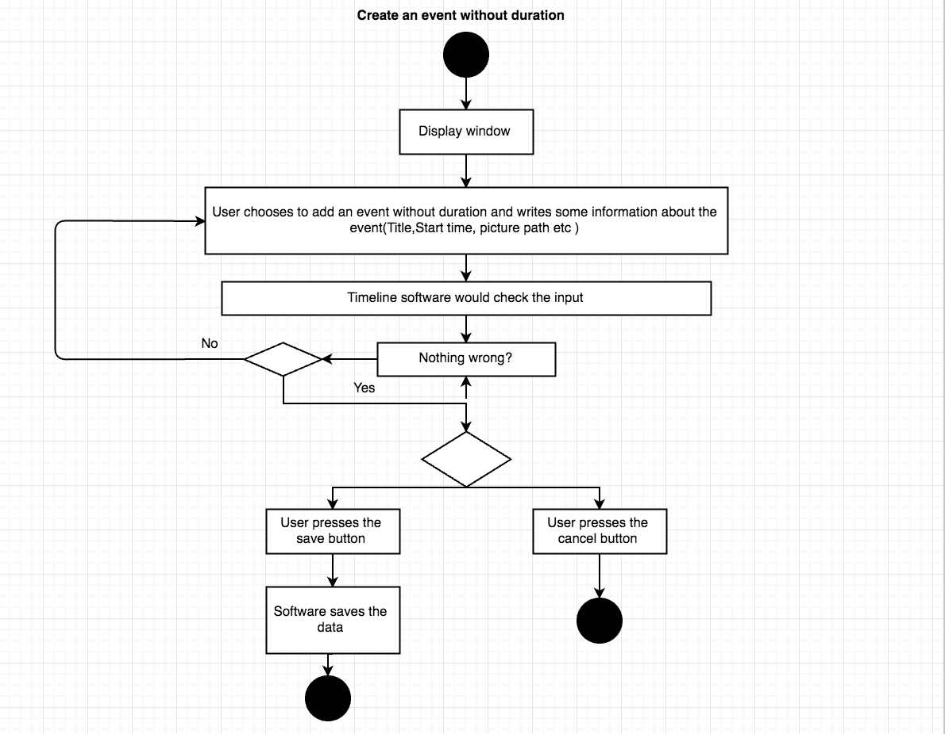

delete event

Preconditions:

1. Software fully loaded on the device.
2. Timeline has been created.
3. Event has been created.

Description: The user clicks on Edit 🡪 Event 🡪 Delete. A new window appears, asking the user if they are sure they want to delete the event. User clicks on the “delete” button. The new window disappears. The event disappears from the current timeline. The software deletes the event from the text file.

Exceptions: Display mode does not give you the option to edit or create an event. When the user clicks on the “cancel/no” button, the new window disappears (nothing gets deleted).

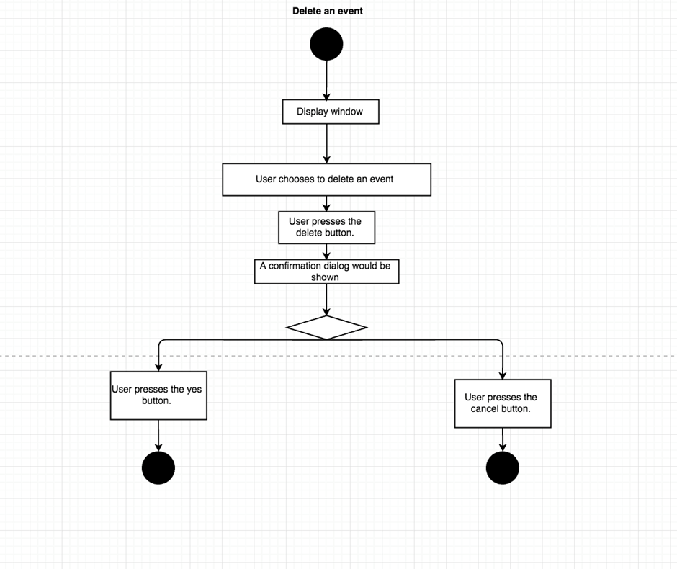

delete timeline

Preconditions:

1. Software fully loaded.
2. Timeline has been created.

Description: The user clicks on Edit 🡪 Timeline 🡪 Remove. A new window appears, asking the user if they are sure they want to delete the timeline and the events. User clicks on the “delete” button. The new window disappears. The timeline disappears from the current timeline. The software deletes the timeline and its events from the text file.

Exceptions: Display mode does not give you the option to edit or create an event. When the user clicks on the “cancel/no” button, the new window disappears (nothing gets deleted).

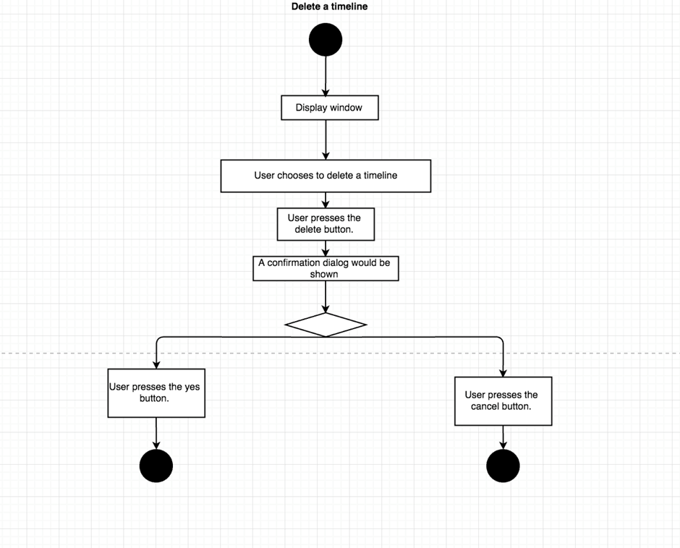

Exit application

Preconditions:

1. Software fully loaded.

Description: The user clicks on File 🡪 Exit. The software shuts down.

Exceptions: (no exceptions)

search event

Preconditions:

1. Software fully loaded.
2. Timeline has been created.
3. Event has been created.

Description: The user clicks on the search bar. The user writes in the name of the event. The software highlights the event on the timeline.

Exceptions: If there is not anything to highlight, nothing happens.